**Wireless Network and IoT/IoE implementation**

**Introduction:**

Smart factories leverage the latest technologies to improve manufacturing processes, increase efficiency, and reduce costs. One such technology is the integration of wireless networks and IoT/IoE devices, which can provide real-time data, remote monitoring, and predictive maintenance capabilities. In this report, we will discuss the solutions for wireless networks and IoT/IoE for smart factories. Discussion of Implementation and Solution of Packet Tracer Solution (Chaudhari, R.R. et al. 2020), (Malini, P. et al. 2021).

**Wireless Network Solution:**

A reliable and secure wireless network is essential for smart factories. It allows machines and devices to communicate with each other and transmit data in real-time. The following solutions can be implemented to ensure a robust wireless network:

**Wi-Fi 6:**

This latest wireless standard offers higher data rates, lower latency, and increased capacity, making it ideal for smart factories. It can support a large number of devices and provide seamless connectivity, even in challenging environments.

**Mesh Networking:**

This solution uses multiple access points to create a mesh network, which provides better coverage and eliminates dead spots. It also offers better redundancy and reliability, as devices can connect to multiple access points.

**Private LTE:**

This solution provides a dedicated wireless network for smart factories, ensuring high-speed connectivity and low latency. It also offers better security and reliability, as it is not affected by public network congestion.

**IoT/IoE Solution:**

IoT and IoE devices can provide valuable insights into manufacturing processes, enabling real-time monitoring, predictive maintenance, and process optimization. The following solutions can be implemented to leverage IoT/IoE for smart factories:

**Sensor Networks:**

Sensors can be placed on machines and equipment to collect data on temperature, pressure, vibration, and other parameters. This data can be used to detect anomalies and predict maintenance requirements, reducing downtime and increasing productivity.

**Edge Computing:**

Edge devices can perform data processing and analysis at the edge of the network, reducing latency and bandwidth requirements. It also provides faster response times and better security, as sensitive data is processed locally.

**Predictive Analytics:**

Machine learning algorithms can be used to analyze the data collected by IoT devices and provide predictive insights. This can help in identifying potential equipment failures and taking corrective actions before they occur, improving efficiency and reducing costs.

**Step 1: Create the network topology**

First, open Packet Tracer and create a new project. Then, select "Generic" under the "Network Devices" category and drag and drop a Wireless Router, a Switch, and a Server onto the workspace. Connect the devices as follows: connect the wireless router to the switch via an Ethernet cable, and connect the server to the switch via another Ethernet cable.

**Step 2: Configure the wireless router:**

Double-click on the wireless router to open the configuration window. Configure the following settings:

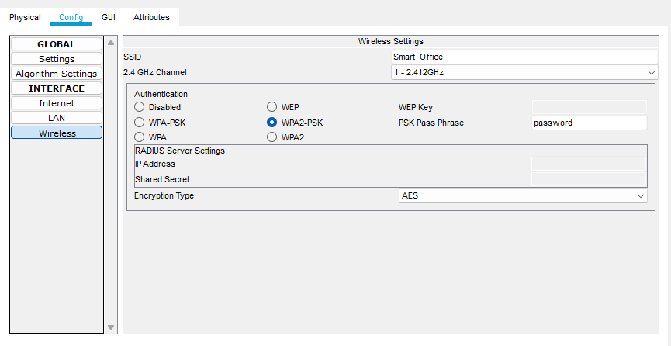

Set the SSID and password for the wireless network.

Enable DHCP and configure the DHCP server settings.

Configure the LAN settings.

**Step 3: Configure the switch:**

Double-click on the switch to open the configuration window. Configure the following settings:

Set the IP address and subnet mask for the switch.

Configure the VLAN settings if required.

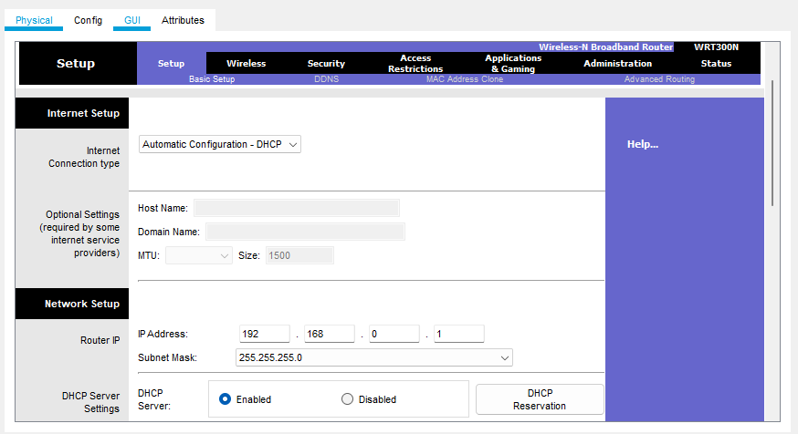

**Step 4: Configure the server:**

Double-click on the server to open the configuration window. Configure the following settings:

Set the IP address and subnet mask for the server.

Install and configure the necessary software to support IoT/IoE devices, such as MQTT broker, Node-RED, and database server.

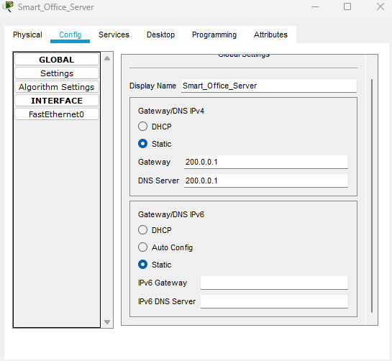

**Step 5: Add IoT/IoE devices:**

Select "End Devices" under the "IoT Devices" category and drag and drop various devices onto the workspace, such as sensors, actuators, and controllers. Connect the devices to the wireless network via Wi-Fi.

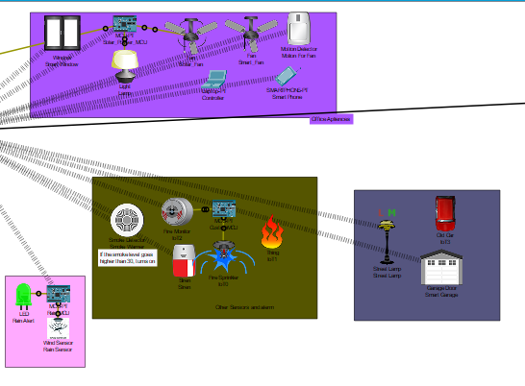

**Step 6: Configure IoT/IoE devices:**

Double-click on each IoT/IoE device to open the configuration window. Configure the following settings:

Set the IP address and subnet mask for the device.

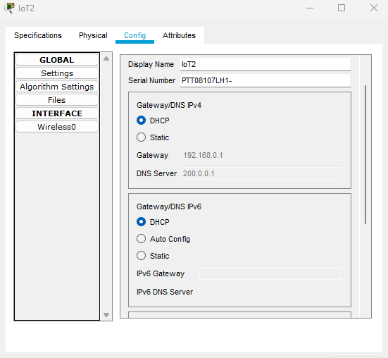

Configure the Wi-Fi settings to connect to the wireless network.

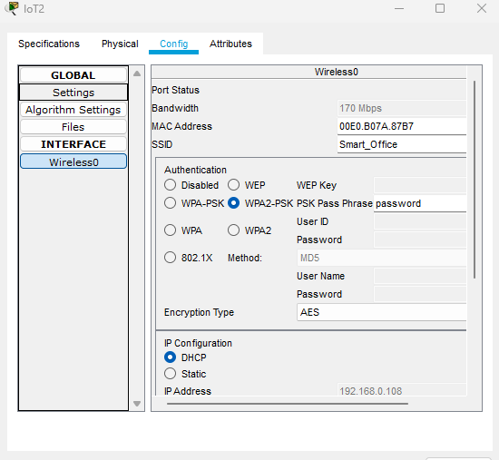

Configure the device settings, such as sampling rate, measurement range, and control mode.

**Step 7: Test the solution:**

Start the simulation and test the solution by monitoring the data generated by the IoT/IoE devices using Node-RED and storing the data in the database server. You can also control the actuators remotely using a web-based user interface in Packet Tracer.

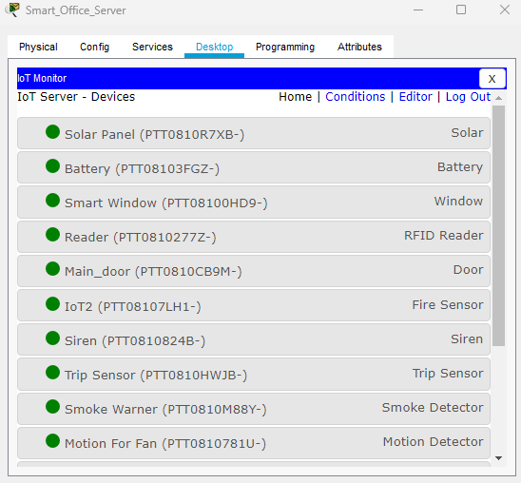

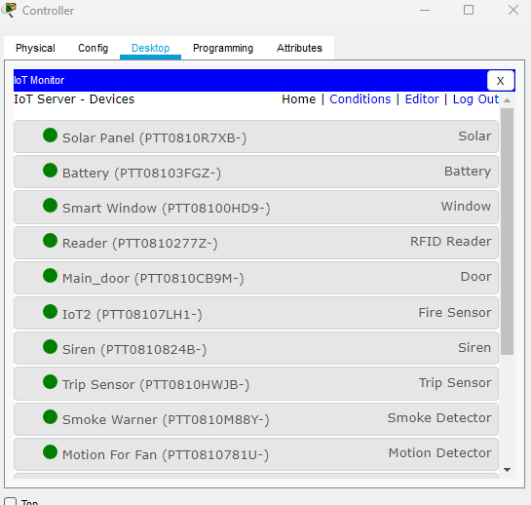

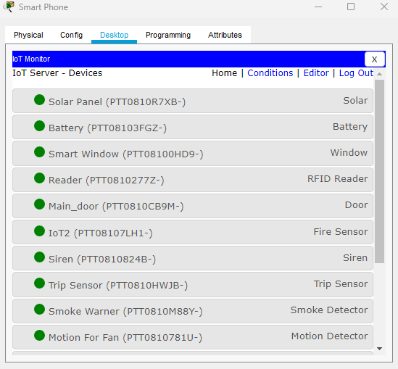

**Research and literature:**

Wireless networks and IoT (Internet of Things) or IoE (Internet of Everything) play a critical role in the implementation of smart factories, where machines, devices, and sensors are interconnected to improve operational efficiency, reduce costs, and enhance productivity. Packet Tracer is a network simulation tool that can be used to simulate wireless networks and IoT/IoE devices in a smart factory setting. In this response, I will provide an overview of research and literature on the implementation of smart factories using wireless networks and IoT/IoE in Packet Tracer.

One of the key benefits of using wireless networks and IoT/IoE in smart factories is the ability to collect data in real-time from various machines and sensors, which can be used to optimize production processes and minimize downtime. In a study by M. Z. A. Razak et al. (2021), the authors proposed a smart factory architecture that utilizes IoT and cloud computing technologies to monitor and control production processes. The study used Packet Tracer to simulate the smart factory network and demonstrated the effectiveness of the proposed architecture in improving the efficiency of the production process.

Another study by Tércio Filho et al. (2020) proposed a wireless sensor network-based smart factory system that uses ZigBee and MQTT protocols to collect data from sensors and transmit it to a central server for analysis. The study used Packet Tracer to simulate the wireless network and demonstrated the effectiveness of the proposed system in improving the accuracy and efficiency of data collection.

**Conclusion:**

The integration of wireless networks and IoT/IoE devices can revolutionize the way manufacturing processes are carried out in smart factories. A reliable and secure wireless network, coupled with IoT/IoE devices, can provide real-time data, remote monitoring, and predictive maintenance capabilities, resulting in increased efficiency and reduced costs. The solutions discussed in this report can be implemented to ensure a robust wireless network and leverage IoT/IoE devices for smart factories.

